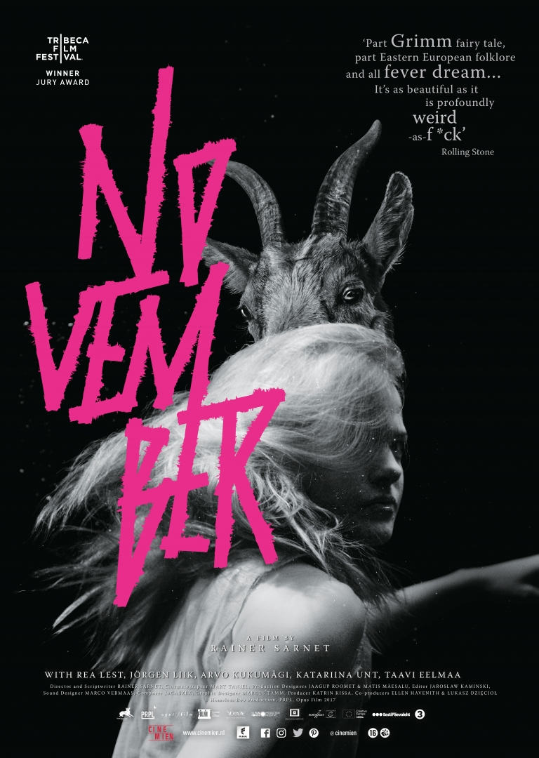

November is vanaf 24 mei te zien in de filmtheaters

Nederlandse synopsis

November is een mix van zwarte magie, humor en romantiek.

Sarnets film is een donker sprookje over een onbeantwoorde liefde, de film is gebaseerd op een bekende Estlandse cult roman. In deze film komen heidense verhalen en Christelijke mythen samen. Het verhaal speelt in Estland, een plek waar weerwolven leven, de pest heerst en geesten ronddwalen. Overleven in deze ruwe samenleving is niet makkelijk. Het boerenmeisje Liina is verliefd op dorpsjongen Hans. Hans is dolverliefd op een Duitse barones die alles behelst wat hij zoekt in een vrouw. Liina geeft niet op en gaat de strijd aan om Hans te winnen. Het wordt een zoektocht van de ene ziel naar de andere, wanneer verkoop je je ziel en hoe leef je verder zonder ziel?

Distributie Benelux Cinemien
‘Chateau’
Gedempt Hamerkanaal 139
1021 KP Amsterdam
The Netherlands
020 5776010
www.cinemien.nl

Publiciteit
Manon de Weerd
manon@cinemien.nl
06 817 90 714

Marketing
Tessa Jansen
tessa@cinemien.nl
06 512 63 675

"November" by Rainer Sarnet

About the film

Rainer Sarnet was drawn to the book by Andrus Kivirähk because of the animism, the belief that all things have a soul. Everything has a soul and this is the central theme of the film - selling one’s soul, living without a soul and longing for a soul.

The story mixes Estonian fairy tales with Christian mythology.

Fairy tales have a fantastical enchantment of beauty and longing. There are ghosts and supernatural forces, and everything is possible. Mortal man is connected to a world greater than himself, which gives him infinite perspective and strength. Fairy tales are spun from the rites of dead religions, where the central image is one of judging a person’s soul in order to glean the person’s worth.

Comparing to the fairy tales from other cultures, Estonian ones are very pragmatic - it always about how the fox cheats the wolf, or steals some milk etc. The farmers build a Kratt who would work for them and steal for them. In Estonian stories it's not important either Devil or God, a wise man cheats them all.

In "November" Estonian fairy tales have been taken apart and reconstructed so that the pragmatic and greedy motives, as well as the darker and uglier side of human nature of the characters are revealed. Far from being just a satire about stealing, the story touches something much more primordial. It is comical not for the stealing, itself, but for the explicitly numb and calm way that people steal. “November” is no museum folklore, it is a description of a black conscience and the love story in it is more of a soul yearning to escape from that kind of a material world.

Stylistically, it is like a careless, wide brush stroke that spills out over the edges a bit, full of dark comedy, romance, magic and horror.

The visual concept of the film is based on Estonian photographer Johannes Pääsuke’s farmer photographs from the beginning of the 20th century. The main, visual idea is to present the environment as documentary fact and avoid ethnographic embellishments. Ramshackle buildings, wet, muddy farmyards, low ceilings and dirt floors, with farm animals in the living quarters. Those photos show wretchedness of the farmers’ lived, and yet, the light in his photos somehow makes it all magical and unreal.

High contrast between dark and light, lucid streaks of light next to pitch-black darkness. The film’s fairy tale-like fantasy elements should be balanced with environments that are as realistic as
possible and natural-looking characters and costumes.

The cast:
The cast for the film is a combination of professional actors and non-professionals. The emphasis was on genuine characters. The non-professionals were often chosen from the countryside, from small villages and one even came from a house in the forest, where she has been living for decades almost in solitude.

The fantacy characters, the KRATT creatures, are robust, constructed by farmers from whatever materials they have at hand. The Kratt’s movements were filmed naturally to retain their clumsy genuineness and proper gravitation. We wanted to avoid any modern VFX and our aim was to go back in time with all the tricks and try to do everything on set. The Kratts were controlled like marionettes and the wires and strings were deleted later. Our aim was to think about the tricks more like Cocteau instead of modern solutions.

The shooting period:
The film was shot during two years starting in 2014 and ending in 2016 with a total of 60 shooting days.
The film is a co-production between Estonia, the Netherlands and Poland.

Homeless Bob Production brought home the first ever Estonian Venice IFF Award with Veiko Õunpuu’s “Autumn Ball”, a film also named the most important film in the last 100 years of Estonian film history by critics and aficionadas, and one that won numerous awards at home and abroad.

The Polish co-producer OPUS FILM is one of Poland’s leading companies that produces features and TV productions on a world scale. In 2015, Opus Film won the Oscar for the Best Foreign Language Film with “Ida” by Pavel Pavlikowski.

PRPL, from the Netherlands, produces films with strong director signatures. One of their latest, “The Paradise Suite” by Joost van Ginkel, was the official entry from the Netherland for the Academy Award Foreign Language Film in 2016.

